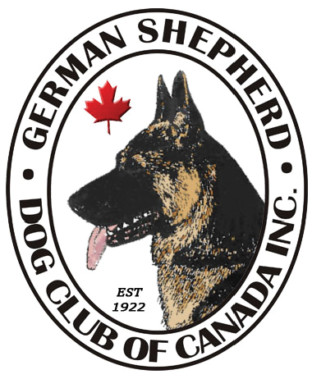
Wild Rose Branch

MID-WEST FUTURITY / MATURITY

SHOW CATALOGUE

Saturday, July 30, 2022
Spruce Meadows, Calgary, Alberta

Judge: Maria McDonald
Show Secretary: Carolin Glimpel

German Shepherd Dog Club of Canada Inc. Executive:

President: Bill Randall
1st Vice President: Molly Snider
2nd Vice President: Donna Conod
Secretary: Tom Morgan
Treasurer: Kay Calvin

MID-WEST FUTURITY / MATURITY

Judge: Maria McDonald

FUTURITY
 | DOGS | BITCHES
Junior |  | 2
Teenage | 1 | 3
Intermediate |  | 4
Senior | 2 | 1
TOTAL | 3 | 10

MATURITY
 | DOGS | BITCHES
 | 1 | 1

FUTURITY

Dogs – Teenage
10  abs | Maxcell’s Southern Man 05-28-21 Breeder: Leslee Innes, Drew Innes by Ch K-Brook The Davinci Code Joelle v Ch Maxell’s Missundaztood Owner: Jodi Voss

Dogs – Senior
11 | Edale’s Cairo 01-30-21 Breeder: Stuart Birch, Sharon Birch by Ch Karizma’s Ike of Edale v Edale’s Havana Owner: Yvonne Soong
12 | Edale’s Lockdown Kaleef 01-30-21 Breeder: Stuart Birch, Sharon Birch by Ch Karizma’s Ike of Edale v Edale’s Havana Owner: Stuart Birch, Sharon Birch
1st 11 2nd 12

Futurity Dog 11 Reserve Dog ___12___

FUTURITY

Bitches - Junior
13  abs | Qisma’s Gossip Girl Aviator Nobler 08-18-21 Breeder: Emily Lenehan by Ch Timberline’s Hard Rock Town v GrCh Qisma’s Blue Savannah Nobler RN Owner: Emily Lenehan
14 | Billyjo’s Back To Black El Shaddai 10-07-21 Breeder: William Randall, Carolin Glimpel by Billyjo’s Prism v El Shaddai v Ch. Billyjo’s Lydia v El Shaddai Owner: William Randall, Carolin Glimpel

1st ___14___ 2nd ________

Bitches – Teenage
15 | Maxcell’s K-Brook Beautiful Trauma 05-28-21 Breeder: Leslee Innes, Drew Innes by Ch K-Brook The Davinci Code Joelle v Ch Maxcell’s Missundaztood Owner: Leslee Innes, Kaye Brooks, Sandi Zacher, Joanne Richards
16  abs | Prairieside’s I’ve Got A Girl Crush 08-31-21 Breeder: Kristin Sapinski by Ferrari vom Funkenspiel v Legend’s Double Vision Owner: Kristin Sapinski
17 | El Shaddais Lexus v Billyjo 06-05-21 Breeder: Carolin Glimpel, William Randall by Ch Edale’s Rockstar K-Brook v Hanna von Calvo Owner: Carolin Glimpel, William Randall

1st ___17___ 2nd ___15___ 3rd __________

Bitches - Intermediate
18  abs | Qisma’s Front Page News Nobler 03-08-21 Breeder: Emily Lenehan by Ferrari vom Funkenspiel v GrCh Qisma’s Autumn Breeze Nobler RN Owner: Emily Lenehan, Diane Kingston
19 | Qisma’s Freya June 03-08-21 Breeder: Emily Lenehan by Ferrari vom Funkenspiel v GrCh Qisma’s Autumn Breeze Nobler RN Owner: Emily Lenehan
20  abs | Qisma’s Fire Lily 03-08-21 Breeder: Emily Lenehan by Ferrari vom Funkenspiel v GrCh Qisma’s Autumn Breeze Nobler RN Owner: Sandy MacFarlane, Emily Lenehan
21  abs | Qisma’s Fable Suzanna 03-08-21 Breeder: Emily Lenehan by Ferrari vom Funkenspiel v GrCh Qisma’s Autumn Breeze Nobler RN Owner: Faith Loewen

1st ___19___ 2nd ________ 3rd_________

Bitches - Senior
22  abs | Edale’s Marrakesh Kaleef 01-30-21 Breeder: Stuart Birch, Sharon Birch by Ch Karizma’s Ike of Edale v Edale’s Havana Owner: Stuart Birch, Sharon Birch

Futurity Bitch ___14 Reserve Bitch ___19___

BEST IN FUTURITY ___14 BEST OPPOSITE___11___

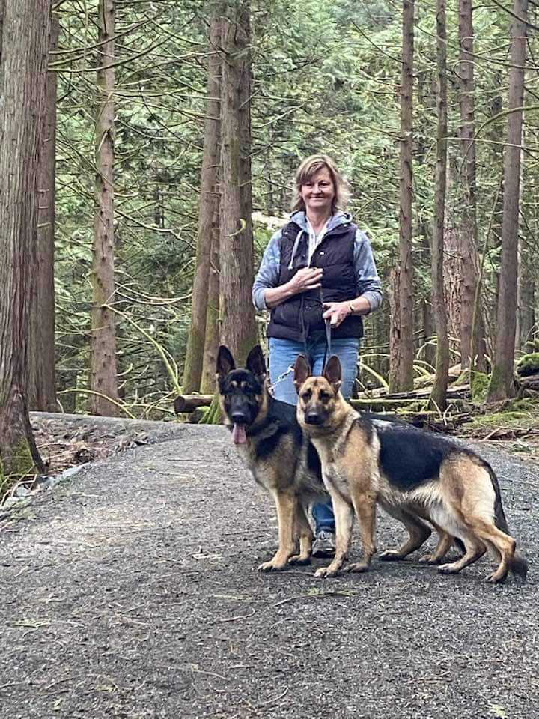
About our esteemed judge Maria McDonald

I have been actively involved with the German Shepherd Dog for 26 years. I have bred 43 Canadian Champions and 7 American Champions under the Kohlein prefix. Along the way I have bred dogs that have earned multiple Best in Shows, Best in Specialty Shows and Best Puppy in Shows. I have also bred many Best in Futurity and Mautrity dogs; as well GSDs who have earned obedience and agility titles.

MATURITY

Dogs
30  abs | Nobler’s Elton Aviator Qisma 03-15-20 Breeder: Lori Iverson, Diane Kingston, Emily Lenehan by Ferrari vom Funkenspiel v GrCh Qisma’s Autumn Breeze Nobler RN Owner: Sandy MacFarlane, Bruce MacFarlane
Bitches
31  abs | Norberge To Boldly Go of Clayfield 12-16-19 Breeder: Pamela O’Dell, Michael Avery, Sharon Avery by Rosewood’s Galileo v Norberge’s Razzle Rosarita of Clayfield Owner: Kristin Sapinski, Pamela O’Dell, Michael Avery, Sharon Avery

BEST IN MATURITY ____________

Brought to you by:

German Shepherd Dog Club of Canada Inc.
Wild Rose Branch

President: Kay Brooks
Secretary: Carolin Glimpel
Treasurer: Lori Iverson
Members: Leslee Inness, Carolyn Ayre, Bill Randall,
Lu Derksen, Emily and Sean Lenehan

Thanks for entering, attending and supporting the
Mid-West Futurity / Maturity Shows!!

